Maestrowu

Group
Krusty Crab
s1163015 Yun
s1163027 Andrew
s1163028 Joe
s1163040 Zaria
s1163042 Huan

Table of contents

Introduction
STP
Segmenting
Targeting
Positioning
4P
Product
Pricing
Promotion
Place
3P
People
Process
Physical evidence

Conclusion
Referrences

Introduction
The 44-day August 23 Artillery Battle, which saw over 470,000 shells raining down on Kinmen like madness; during the Cold War between the Kuomintang and the Chinese Communist Party in the 1950s, the Communist forces also dropped over 600,000 propaganda shells on Kinmen. These seemingly unbelievable numbers have contributed to Kinmen's abundant original steel, which is now used to craft the renowned Kinmen Steel Knives.
In contrast to regular steel, the steel used in shells is denser, with more precise structure, making it incredibly durable and sharp. These qualities make it advantageous for crafting knives, but also demand rigorous craftsmanship due to the denser steel. With polishing techniques refined over nearly eighty years of experience, MaestroWu Steel Knives undoubtedly stand out as the top contenders in the industry in every aspect.
Malaysia is a densely populated country with a significant potential market. Due to the large Chinese population in Malaysia, Chinese culture has also greatly influenced the country. In terms of culinary habits, both Malaysia and Taiwan emphasize Chinese cooking methods such as stir-frying, boiling soups, and steaming dishes. Many ingredients require cutting, chopping, and slicing, such as fish, meat, and vegetables, which demand high-quality, durable, and sharp knives.

The new generation of Kinmen steel knives focuses on practicality and functionality, with blades that emphasize beauty and modernity in design. The materials used are selected high-hardness RC58 shell steel, capable of easily handling various complex food preparation tasks.

STP
Segmenting
- Demographic
- Race: Bumiputera → 61.8%
Chinese → 21.4%
Indian → 6.4%
Others → 0.9%
Non-Malaysia Resident → 9.6%

- It’s important to grinding spices, chilies and pastes.
- Typical dishes includes one chicken or fish dish cooked with coconut or tamarind, fried fish, stir-fried vegetables, and sambol belacan.
- Nasi lemak with beef or chicken rendong, squid sambal, stir-fried morning glory, fried eggs/chicken.
The ingredients will not be overcooked and seasoned with spices. The knife should be like basic bone chopping knife, vegetable knife or beef knife.

- Salary - Bottom 40% < RM5,250 ($36.103/month)
- Middle 40% 5,251<X<11,819
- Top 20% > RM11,820 ($81,284/month)

- Geographic
- West - Peninsula (11 states & 2 federal territories)
- East - Borneo (Sabah, Sarawak, Labuan)
→ divided by the South China Ocean

- Behavioral
- Average consumption in Kuala Lampur:
RM1,138/month (Male:RM1,067/Female:RM1,209)
- Online shopping average cost:
RM463/month (Male:RM430/Female:RM496)

Non-essential items purchase | Online | Physical store
Apporel | 37% | 39%
Electronic product | 22% | 16%
Gifts | 12% | 10%
Kitchen utensils | 6% | 10%
Home decoration | 5% | 9%
Toy | 5% | 4%
Others | 13% | 12%

Targeting
The price of our basic knives falls between 1,300 and 2,500, and the price of collectible knives falls between 4,000 and 6,000. Top 20 percent of high income customers and middle 40 percent of customers are more suitable to be our target customer.

Positioning
Figure shows our positioning in the market is focused on the top 60% of customers. Most of the products we sell are functional and emphasize high quality. It is a daily necessity commonly used in ordinary households. A small number of knives have collectible value but are relatively expensive. They are provided to the high-income customers who pursue high quality of life.

Figure 1 - Positioning map
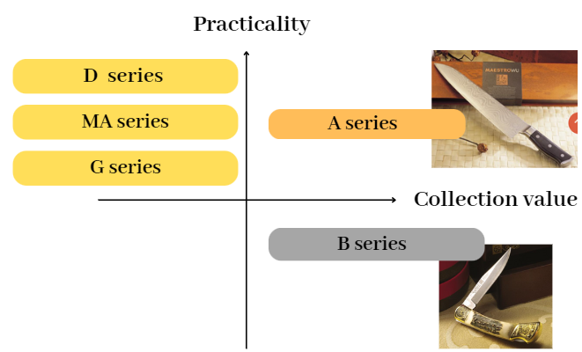
As we can see in the figure 1, we will sell our product MA series to Malaysia. This series contains basic chopping knife to meat knife, providing high practicality with affordable price. The A and B series in figure 1 named 雲遊龍紋家庭/收藏鋼刀, the average price is around 5,000 dollars. The market for these kinds of products is only suitable for high-income families.
4P
Product
Wu Zeng-Dong, with his exceptional knife-making skills and ingenuity, has transformed "bomb steel" into the internationally renowned "MaestroWu Steel Knives." Master Wu's continuous pursuit is to find the perfect balance between tradition and innovation. To achieve this, he has collaborated with top Japanese industrial designers to create new value for MaestroWu. The new generation of Kinmen steel knives emphasizes practicality and functionality, with blade designs that combine aesthetic appeal and modernity. Made from specially selected RC58 high-hardness bullet steel, these knives are considered masterpieces of craftsmanship, infusing a century-old shop with an international perspective.
Figure 2- schematic
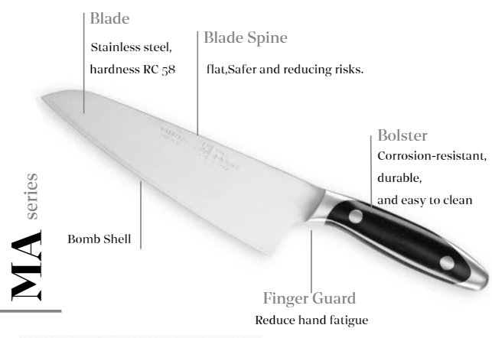

Price
Basic:
- Made from standard RC58 high-hardness bombshell for basic quality assurance.
- Simple, practical design suitable for everyday kitchen use.
- Affordable pricing for budget-conscious consumers or first-time buyers.
Mid-Range Products:
- Further processed and treated RC58 high-hardness steel for enhanced durability and sharpness.
- Balanced design between aesthetics and practicality, with refined blade shapes.
- Additional features like non-slip handles or special blade treatments.
- Priced at the mid-range level, targeting households with higher quality demands or amateur chefs.
High-End:
- Highest quality RC58 high-hardness bombshell processed with advanced techniques.
- Unique design blending modern art and traditional craftsmanship, with high artistic and collectible value.
- Supervised by MasterWu Zeng-Dong for exquisite craftsmanship.
- Priced at the high-end level, targeting professional chefs, high-end restaurants, and discerning knife enthusiasts.
- Offers custom services with unique serial numbers and certificates.
Limited Edition and Commemorative:
- Produced in limited quantities for rarity and collectible value.
- Unique designs and stories, possibly commemorating events or individuals.
- Exquisite packaging with detailed descriptions and production insights.
- Priced at the highest level, targeting collectors and the luxury gift market.
- Sold through auctions or specific channels to enhance exclusivity and prestige.

Place
In January 2020, the Hong Kong Trade Development Council conducted a study in Kuala Lumpur using focus groups and online surveys to understand the shopping behaviors and preferences of local consumers both online and offline. The study gathered opinions from 1,500 respondents and found that local consumers frequently visit malls, with 74% indicating they go to a mall at least once a month. Additionally, mobile commerce performed exceptionally well, with 53% of respondents primarily using smartphones for shopping. Therefore, we have divided our sales channels into online and offline.
- Online Channel
Malaysia's e-commerce market is rapidly developing into one of the largest in Southeast Asia. In 2022 alone, Malaysia's e-commerce grew by 20%. In recent years, this growth has been accompanied by a trend towards online shopping and a variety of payment options. In 2023, the Malaysian e-commerce market is expected to reach USD 10.19 billion, and by 2027, it is projected to reach USD 16.98 billion, with a compound annual growth rate of 13.6%.
"Shopee" is the most popular e-commerce platform among Malaysian consumers. It offers numerous discounts, cashback, and free shipping vouchers, along with a well-established logistics system and a complaint resolution mechanism. This makes it the preferred platform for online shopping in Malaysia and a significant consideration for Taiwanese online shoppers. Hence, MaestroWu has chosen to set up a store on Shopee, selling basic knife models. This not only expands market coverage but also enhances brand awareness and sales.
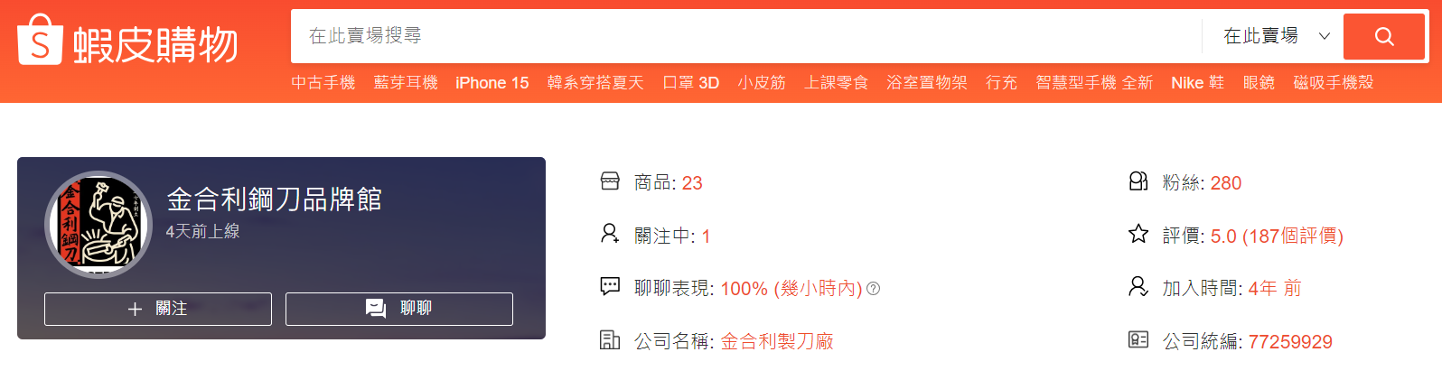
Figure 3- Shopee
- Offline Channel
The most popular shopping destination among local consumers in Kuala Lumpur is 1 Utama, commonly referred to as 1U. Despite being a 30-minute drive from the city center, 11% of respondents stated that they regularly shop at 1U. It is a massive shopping mall with over 700 stores, including fashion brands, restaurants, entertainment facilities, supermarkets, and more. As a high-end shopping center, 1 Utama attracts many quality and brand-conscious consumers. This aligns perfectly with Jinhe Li’s emphasis on craftsmanship and brand value, helping to attract target consumers. Additionally, the high foot traffic means more potential customers, which can boost sales. Therefore, setting up a store in 1 Utama would be an ideal choice forMaestroWu.

Promotion
In Malaysia, 99.9% of online consumers use social media, with Facebook being the most popular at a usage rate of 90%, followed by Instagram at 82%. The most commonly used messaging apps are WhatsApp and Facebook Messenger, with usage rates of 94% and 70%, respectively.
1.Social Media:
To effectively penetrate the Malaysian market, MaestroWu can manage a Malaysian Facebook fan page and an Instagram account, quickly accumulating a local customer base. Initially, the brand can use simplified Chinese for its social media content and later incorporate English and Malay to better integrate into the Malaysian market with localized elements. Additionally, Malaysian consumers typically contact customer service before making their first purchase of overseas products. We can establish a comprehensive local customer service process through Facebook Messenger and WhatsApp to enhance local consumers' confidence and favorability towards the brand.
2."short video" is Mainstream:
According to social media data from various countries, 98% of internet users in Malaysia are accustomed to watching videos online. Therefore, 15-second short videos, vlogs, unboxing videos, and other dynamic content can effectively attract local consumers. We can create short videos showcasing the knife-making process, historical background, or interesting facts about knives like TMI.(which are particularly popular among the younger generation) to enhance brand promotion effectiveness.

3P
People
Knife maker
We insist on handcrafted knife-making. In order to prevent counterfeiting, our founder pioneered the practice of making knives from bullet shells specified on-site. Our knife-making masters must have high requirements for themselves, at the same time, they must have modern aesthetics and international vision.

Physical store employee
To be a worker in Maestrowu’s physical store in Kuala Lampur, it need to understand our brand story and production process. The production method and the business philosophy of Maestrowu are so important points that cannot be ignored by customers. In addition, staff training is also important to make customers feel at home during the service process. While being comfortable, they can also feel the elegance and high-end of our products.

Online customer service
As we mention in the online channel, Shopee is the most popular e-commerce platform among Malaysian consumers. We know that Maestrowu already has an exclusive official Shopee account, and then we needs local online customer service to provide immediate message responses. Just like the employees in physical stores, the service process requires courtesy and quality. Customer service must have a certain degree of professionalism to answer customers' more detailed questions about our products.
Shopee currently attracts approximately 55 million visitors each month, Cross-border spending accounts for 40% of all e-commerce in the country. 80% of smartphone users use mobile devices for online shopping. Understand the customs, traditions and festivals that affect local customers’ shopping behavior, classify customers, and increase conversion rates through customized content marketing and conversion with consumers.

Process
Possible problems:
- Not sure what kind of knife do they need, and can’t choose which one is more suitable, wooden handle or steel handle?
- Solve: Customers can tell the staff their expected price range or their usual eating habits. We can make a customized shopping plans for our customer to help them make better decision.
- Except for areas such as the Klang Valley, most e-commerce goods in Malaysia take more than 2 days to be delivered.
- Solve: Some consumers are willing to pay extra for faster delivery. We allow customers to track deliveries in real-time so they don’t have to guess when their goods will arrive. The key to delivering a superior shipping experience is having unified inventory across our stores, warehouses and other order fulfillment centers.
- Internet consumer security
- Malaysian government is reviewing the proposed issuance of special licenses for Malaysian e-commerce merchants to enhance the safety of people's online shopping.
- Warranty issues
- Set up a maintenance department in a store. Whether it is a physical purchase or an online purchase, you can return to the store for maintenance or repair of tools. It can enhance the after-sales service experience.

Do as one likes: Electronic wallet, credit card swiping, customer service
The concept of cashless payment has become popular in Malaysia. Shopee and Lazada have their own e-wallets, allowing consumers to obtain cash rewards through stored-value e-wallets, and cooperate with specific merchants to reduce shipping costs, which has successfully attracted many consumers. . If there are no free shipping and reduction activities, most Malaysian consumers will choose to swipe their cards to make purchases.
In addition, as online shopping becomes more and more developed in Malaysia, customer service has also become a very important role for online shopping platforms. In most reports, many platforms have been criticized for poor customer service quality, poor attitude, ignorance of questions, slow speed, etc. It can be found that The importance netizens attach to the customer service of online shopping platforms.

Physical evidence
Engraving services: The engraving service is based on a single piece and a single side, and the maximum number of words at one time is 20. Whether it is for gift giving or for personal use, this service injects extraordinary meaning into the product.
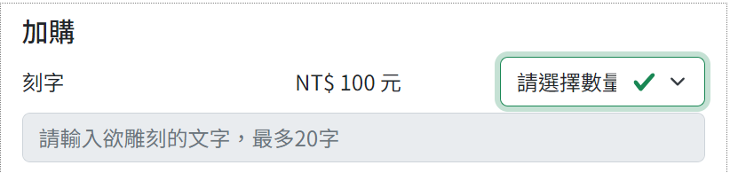
Figure-4
Historical wall: We can set up a historical wall in our physical store, customer can feels like attending an exhibition while they are shopping. Currently, Maestrowu’s brand story can only be seen on the official website. We hope that through the pictures on the wall, customers can see the image of Master Wu still staying by the stove every day, turning "cannonball steel" into something magical.

Conclusion
- Maestrowu knives were born from Wu Jun's extraordinary ingenuity and creativity. In the past few generations, they have continued to integrate old and new ideas and introduce new ones. Now we want to export our product to Malaysia. In addition to the similarity in food culture, the huge consumer base and consumption behavior patterns are also the reason for us to expand our business there.
- In 4p strategy, we emphasize product quality, practicality and functionality. We provide product options from low to high prices according to different product specifications, and use product line pricing strategies to satisfy consumer needs and budgets.
Next, it is divided into online and offline channels: the operation and promotion of Shopee’s official flagship store is particularly important for overseas markets. We must provide real-time online customer service with foreign language skills, patience and professionalism to face customers' more difficult problems. And when it comes to offline channel, we will set up a physical store in 1 Utama, a large department store in Kuala Lumpur. The business philosophy and value of this high-end shopping mall are consistent with Maestrowu, which will make it easier for us to find potential customers.
Last, promotion. Mobile phones are becoming more and more popular in Malaysia. Compared with physical advertising, data tells us that promotion through social media and short videos can bring our products into the public's attention more effectively.
- In 3p strategy, we have mentioned ‘people’ in the front so keep going to ‘process’. From the very beginning of product production, including material selection, quality control, and factory environment, all require strict management. After the product completed, we need to pay more attention to packaging, transportation, sales to after-sales service. We look for problems that are commonly encountered when selling overseas products online, and we provide solutions from our perspective to improve the overall shopping quality. Finally, we provide a more comfortable and advanced shopping experience during the shopping process, including historical walls in physical stores and engraving services for knives, so that customers can buy more than just household items.

Referrences
https://www.i-buzz.com.tw/article/article?atype=crossborder&id=164
https://www.maestrowu.com.tw/about-brand.php
https://research.hktdc.com/tc/article/NTA4MzU4MzYy
https://shopee.tw/maestrowu1937#product_list
https://www.i-buzz.com.tw/article/article?atype=crossborder&id=68

